The random forest model was selected to predict the ticket price over the simple regression as it provided smaller cross-validation mean absolute error and smaller variability. The verification on the test set was also close to the cross-validation results.

The random forest predicted ticket price for the Big Mountain Resort was $94.22 while the averaging pricing strategy was $81. Features that came up as important with a strong correlation to pricing in the modeling included:

* vertical_drop
* Snow Making_ac
* total_chairs
* fastQuads
* Runs
* LongestRun_mi
* trams
* SkiableTerrain_ac

The potential revenue increase could be twenty-three million dollars if the resort chooses to use the predicted model price assuming 350,000 visitors per year with an average of five tickets per stay.

Big Mountain Resort has been reviewing potential scenarios for either cutting costs or increasing revenue (from ticket prices). All four of the scenarios have been modeled and the result is shown below:

Scenario#1: Permanently closing down up to 10 of the least used runs. This doesn't impact any other resort statistics. See the revenue impact in the plot right below.

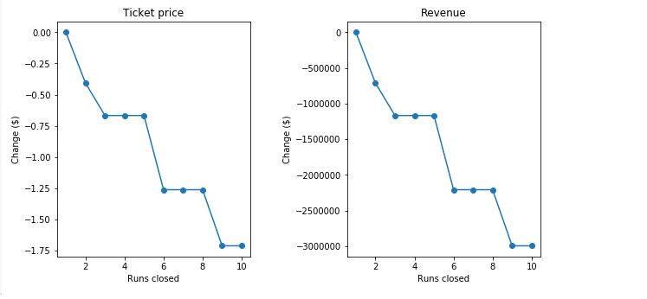

Scenario #2: Increase the vertical drop by adding a run to a point 150 feet lower down but requiring the installation of an additional chair lift to bring skiers back up, without additional snow-making coverage. This scenario increases support for the ticket by $1.99 which will bring in an additional 3.5 million over the season

Scenario#3: Same as scenario#2, but adding 2 acres of snow-making cover. The modeled result is similar to scenario#2.

Scenario#4: Increase the longest run by 0.2milese to boast 3.5 miles length, requiring additional snow-making coverage of 4 acres. The model showed these changes made no change to the ticket price.

The operating cost of installing the additional chair lift was $1,540,000, and the calculated operating cost of the new chair lift per ticket is about $0.88 which is good as the change supports the increase of ticket by $2.

Besides the price data, it would be helpful to have more information below for modeling:

* Is free ski for kids? Price for teen/senior/kid
* Price vs. month
* Visitor driving/fling distance
* maintenance, installation costs for new chair lift

Below are plots comparing Big Mountain Resort vs. all resorts:

